**Name: Abdul Ghaffar Kalhoro**

**Reg: no: 194699**

**Class: BSCS-6C (2nd semester)**

**Lab-6**

**Object Oriented Programming(OOP)**

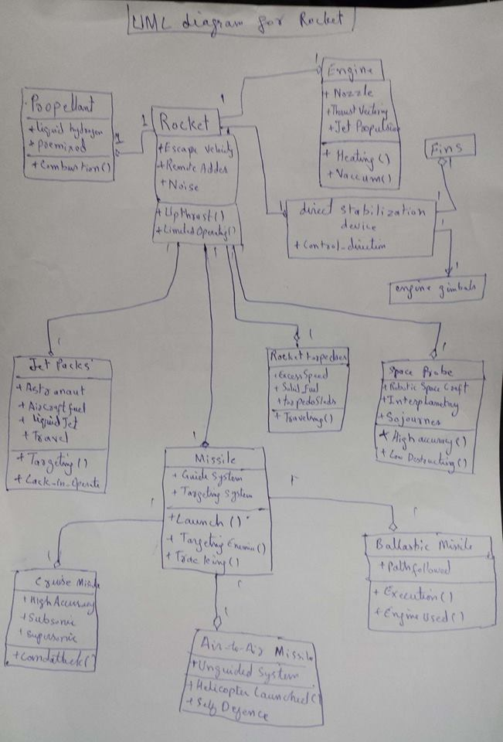

**Source Code for lab_6 Task-1**

**public** **class** Rocket {

//data fields

**public** **double** Escape_velocity;

**public** String RemoteAdder;

**public** String Noise;

//methods

**public** **void** Upthrust(){}

**public** **void** LimitedOperating(){};

}

**class** jetPacks **extends** Rocket{

//data fields

**public** String Astranaut;

**public** String Aircraftfuel;

**public** String liquadJet;

**public** String travel;

//methods

**public** **void** Targeting(){}

**public** **void** Lack_in_Operate(){}

}

**class** Rockettorpedpres **extends** Rocket{

//data fields

**public** String ExcessSpeed;

**public** String Solid_Fuel;

**public** String torpedoSleds;

**public** **void** Traveling (){}

}

**class** SpaceProbe **extends** Rocket{

//data fields

**public** String RoboticSpaceCraft;

**public** String Interplanetary;

**public** String Sojourner;

**public** **void** Highaccuracy (){}

**public** **void** LowDestruction (){}

}

**class** Missile **extends** Rocket{

//data fields

**public** String GuideSystem;

**public** String TargetingSystem;

//methods

**public** **void** Launch(){}

**public** **void** TargetingEnemies(){}

**public** **void** Tracking(){}

}

**class** CruiseMissile **extends** Missile{

//data fields

**public** String HighAccuracu;

**public** String Subsonic;

**public** String supersonic;

//methods

**public** **void** landatack(){}

}

**class** Air_to_Air_Missile **extends** Missile{

//data fields

**public** String UnguidedSystem;

//methods

**public** **void** HelicopterLaunched(){}

**public** **void** SelfDefence(){}

}

**class** Ballastic_Missile **extends** Missile{

//data fields

**public** String pathfollowed;

//methods

**public** **void** Execution(){}

**public** **void** EngineUsed(){}

}

**class** Propellant **extends** Rocket{

//data fields

**public** String liquidhydrogen;

**public** String premixed;

//methods

**public** **void** Combustion(){}

}

**class** Engine **extends** Rocket{

//data fields

**public** String Nozzle;

**public** String Thrust_Velocity;

**public** String jetPropulsion;

//methods

**public** **void** Heating(){}

**public** **void** Vaccum(){}

}

**class** directStabilizationdevice **extends** Rocket{

//data fields

**public** String control_direction;

}

**class** Fins **extends** directStabilizationdevice{

}

**class** engine_gimbals **extends** directStabilizationdevice{

}